**Title: Temporal and Spatial Shifts in Gun Violence, Before and After a Historic Police Killing in Minneapolis**

**Authors:** Ryan P. Larson1*, N. Jeanie Santaularia2, and Christopher Uggen1

**Affiliations:**

1Department of Sociology, University of Minnesota - Twin Cities; Minneapolis, MN

2Carolina Population Center, University of North Carolina; Chapel Hill, NC

* Corresponding author. Email: lars3965@umn.edu

**Abstract:** In 2020, the United States experienced social unrest in response to police killings, and a steep rise in the homicide rate. Among the states, Minnesota experienced the greatest increase in gun violence events (*1*). This report uses hospital discharge data to consider the rate of firearm-related injuries occurring before and after the murder of George Floyd. Interrupted time-series and random effects panel models reveal a rising and falling temporal pattern and a spatial pattern in which disadvantaged, historically Black communities experienced the brunt of the increase. These effects remain after adjusting for changes in police activity and pandemic-related restrictions, indicating that rising violence was not a simple byproduct of changes in police behavior or COVID-19 response. The consequences of police killings and social unrest are disproportionately borne by underserved communities.

**One-Sentence Summary:** Rates of firearm assaults increased after the police killing of George Floyd in Minneapolis, MN, primarily in historically disadvantaged communities and longstanding sites of protest against police violence.

**Main Text:**

**Background**

In 2020, the United States experienced major social unrest and protests against racial injustice in response to several high-profile police killings of Black men and women. The murder of George Floyd, in particular, came to symbolize and represent the fatal consequences of longstanding structures of racial domination in the criminal justice system (*2,3*). These widely reported killings catalyzed the growing social movement #Blacklivesmatter, which brought attention to the long history and contemporary realities of police violence and brutality, particularly against Black people (*4,5*). Specifically, the video recording of the murder highlighted the historic and contemporary racism evident in mass incarceration and the evolving disproportionate impacts of the COVID-19 pandemic on Black people (Wrigley-Field et al. 2021). With the highly publicized murder of Mr. Floyd on May 25th, 2020, these social tensions came to a head in Minneapolis, Minnesota, sparking sustained protests throughout the world. A widely reported spike in gun-related crime emerged after the murder, alongside claims that the rise in violence was due to changes in local police behavior (“de-policing”) in response to protest and social unrest (*6,7*), the COVID-19 pandemic, and a broad national increase in homicide (*8*).

While the fundamental cause of the social unrest was a highly publicized police murder and the structural racism undergirding US policing, there have been two major claims by which this unrest translated into an uptick in gun violence. First, the COVID-19 pandemic heightened visibility of existing vulnerabilities and unequal contexts. The pandemic further weakened formal and informal support systems with stay at home orders and school closings, causing strain and exacerbating inequalities across communities. Second, in the wake of the murder, there could have been changes in police behavior (or “de-policing”) as result of heightened scrutiny and community resistance. Classical deterrence theories (ref?) suggest that a decline in police activity will decrease the perceived probability of apprehension and conviction among potential offenders, and thereby increase the rate of gun assaults. More deeply, the police murder may have catalyzed and augmented collective legal estrangement – the sense among marginalized residents that they exist “within the law’s aegis but outside its protection (BELL, M. C. (2017). Police Reform and the Dismantling of Legal Estrangement. The Yale Law Journal, 126(7), 2054–2150.).” Police killings alienate marginalized communities and undermine trust in legal institutions, which could lead residents to handle grievances using violent “self-help” rather than appeals to police and public authorities (Black, D. (2014). Violent structures. In Violence (pp. 153-166). Routledge.). The heightened legal estrangement in disadvantaged communities of color, combined with the historical legacies of police violence and unequal treatment by legal institutions, could have catalyzed social unrest and fostered gun violence.

Research and public discourse in the aftermath of police violence has emphasized the temporal and spatial pattern of subsequent violent crime (*9, 10*). Studies following the police killings of civilians have focused on the so-called ‘Ferguson effect’ following the killing of Michael Brown in Ferguson, MO. Despite speculation that violent crime increased, particularly gun violence, there was no immediate increase in homicides or other types of violent crime in St. Louis, Missouri (*9, 10*). After the unrest following Freddie Gray’s arrest and killing in Baltimore, however, shootings and homicides increased in the next three months (*11*). To date, the studies investigating these trends and associations have largely analyzed data reported directly from police departments. These data are limited, however, due to 1) selectivity associated with systemic racial biases and the overrepresentation of communities of color in police and court data; and 2) potential misclassification of gun violence due to changes in policing, and to the detection and categorization of crime events, in a time of disruption (*12*). Moreover, the willingness to report to the police is diminished in the aftermath of police violence, especially in communities that are already heavily policed and disproportionately impacted by gun violence (*13*). These points highlight the importance of alternative data sources to track gun violence that are independent of police. Although hospital data are not free of such biases, injury reports offer an independent and potentially more accurate source of information about gun violence.

In light of this background, the current analysis seeks to understand: 1) the temporal and spatial pattern of gun violence injuries in Minneapolis, before and after the police killing of Mr. Floyd; 2) whether the patterns of gun violence injuries mirror those observed after previous police killings in Ferguson, Baltimore or elsewhere; and 3) to the extent that we observe a “Minneapolis effect,” whether disadvantaged communities experienced the greatest increase.

**Methods**

Data

We leverage Minnesota Hospital Discharge data to create our dependent variable, firearm assault injuries per 1,000 residents. Inpatient and outpatient data from 2016-2020 utilizing International Classification of Diseases (ICD)-10 codes X93-X95 were used to define firearm assault injuries.

The key exposure time indicators of interest are the police killing of George Floyd on 5/25/2020 (post-killing), and three months after this event, dated 8/25/2020 (three-months post-killing). These are the focal time indicators of interest in the analysis, and represent changes in firearm assault incidence in those time periods as compared to periods in the preceding period.

To measure the effects of the events of interest and to test the two major claims of the unrest, we create time indicators that measure the average rate in the period as compared to the pre-killing baseline, following previous empirical work on crime rates in Baltimore (5,6). We create event indicators at four key points, two of which are related to the COVID-19 pandemic: 3/13/2020 at the inception of Governor Walz’s State of Emergency order, and from 3/28-2020-5/28/2020 at the introduction and conclusion of this Stay at Home order. These time indicators adjust for changes in firearm assault incidence related to significant policy events in the course of the COVID-19 pandemic and related patterns of social interaction. We incorporate measures of police behavior from the Minneapolis Police Department (https://opendata.minneapolismn.gov/). Specifically, we aggregate reported use of force incidents, police stops, and officer-involved shootings to both the week and ZCTA-week level from 2016-2020, placing each incident in each ZCTA-week by the date of incident and the longitude and latitude coordinates of the location of the event. These measures serve as our focal indicators of policing activity in Minneapolis, and will adjust our event period coefficients for any concurrent changes in police stops, uses of force, or shootings.

We also merge measures of seasonality onto the weekly hospital data. Following previous scholarship (5,6) we include the weekly maximum temperature (degrees Fahrenheit), snowfall (in.), and precipitation (in.) from the Minnesota Department of Natural Resources as measured at the Minneapolis/St. Paul Threaded Record station https://www.dnr.state.mn.us/climate/historical/daily-data.html?sid=mspthr&sname=Minneapolis/St%20Paul%20Threaded%20Record&sdate=2010-01-01&edate=por). A measure of the average weekly number of hours of dark before 12pm is also included as further adjustment for seasonality.[1] Finally, we construct the proportion of days in the week K-12 Minneapolis Public Schools were in session based on school calendars from 2016-2020 (https://mpls.k12.mn.us/calendars). These measures serve as essential seasonal controls that adjust the key time period estimates for expected seasonal changes in gun assault injury.

Spatial Zip Code Tabulation Area (ZCTA) simple feature boundary attributes, and each geography’s corresponding yearly American Community Survey (ACS) data, was accessed from The Census Bureau’s API using the tidycensus package in R (15). These data and boundary attributes can also be accessed through the IPUMS USA dataset (16). A boundary shapefile for the city boundaries of Minneapolis was accessed from the City of Minneapolis’ open data portal (https://opendata.minneapolismn.gov/). ZCTAs representing Minneapolis were determined by spatial intersection with the Minneapolis city boundary. Additionally, intersecting neighbors were defined as > 2 percent spatial overlap to identify ZCTAs that contain enough spatial overlap to have records in the Minneapolis Police Department data. We also acquire ZCTA-year data on percent Black from the American Community Survey 5-year estimates, which serves as our proxy for structural racism and disadvantage in our tests of spatial heterogeneity below.

Statistical Method

Our analytical strategy is two-fold: we first estimate interrupted time-series models on week-level data, then estimate random-effects panel models with random ZCTA intercepts on Zip Code Tabulation Area (ZCTA)-week level data to corroborate the aggregate findings incorporating both within- and between-ZCTA variation. In the week-level interrupted time series model, significant autocorrelation was detected at a lag of 1 in partial autocorrelation functions of the residuals, and therefore an AR(1) component was added to the model to account for this serial dependence. Finally, we estimate a random-effects model with a cross-level interaction between the post-killing indicator and percent Black to examine the spatial heterogeneity in the post-killing effect across communities, and to assess the moderating influence of structural racism and disadvantage on the effect of the police killing (see also Figure 2). All data and code for data manipulation, merging, and analysis, apart from the restricted MHA data, are available in an online GitHub repository..

**Results**

***Temporal Pattern of Firearm Assault Injuries***

Figure 1 displays the weekly incidence of gun assault injuries from hospitals in Minneapolis from 2016-2020. We observe a sharp increase in the firearm assault injury rate from about .006 per 1,000 residents to a peak of .045 per 1,000 residents after the police killing of George Floyd, about a seven-fold increase. After an initial spike, the rate then fell to levels more consistent with the pre-killing period. As we will discuss below (in Figure 4), the peak period for homicides came later and persisted longer than the peak period for gun assault injuries.

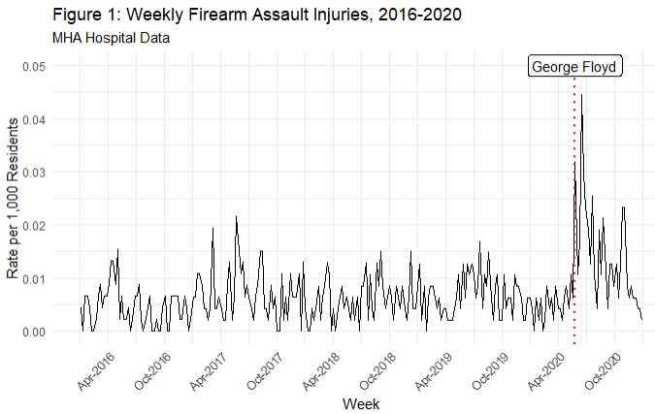

***Spatiotemporal Pattern of Firearm Assault Injuries***

After describing the temporal pattern in Figure 1, we next disaggregate the weekly data to local Zip Code Tabulation Areas (ZCTAs) to analyze the spatiotemporal variation in the rates of firearm assault. Figure 2 displays the firearm rates by Zip Code Tabulation Areas and period. The temporal pattern apparent in Figure 1 emerges, but only for certain ZCTAs. Specifically, areas already marked by higher gun violence in the pre-treatment period experienced greater change across the time periods as compared to ZCTAs with very low firearm assault incidence. The area surrounding George Floyd Square experienced an increase in firearm assault injuries in the three months following his death, but the red area representing the greatest spike is North Minneapolis, a historically Black community and a longstanding site of resistance to police violence and racial injustice. This includes the area of civil unrest on Plymouth Avenue in 1967, in which residents protested against maltreatment by police and local business owners (*14*).

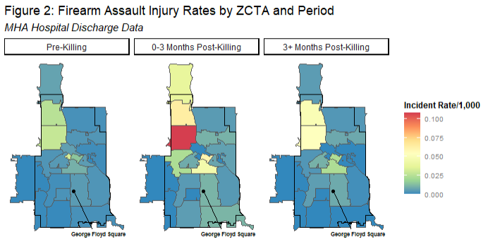

***Interrupted Time Series Models***

Table 1 presents interrupted time series models of the firearm assault injury rate in Minneapolis from 2016-2020. Each model includes a time indicator for each period of analysis, as well as controls for seasonality and police behavior. The seasonality measures account for the *expected* seasonal change in gun assault injuries, and the measures of MPD police activity account for changes in police behavior in the post-killing periods. Model 2 is estimated on disaggregated weekly Zip Code Tabulation Area data, and includes ZCTA random effects to account for the clustered data within ZCTAs across time. Controlling for seasonal expectations, Model 1 indicates that the rate of firearm assault injuries rose in the three months after the killing (labeled Post-Killing in the table), by an average of .015 firearm assault injuries per 1,000 residents. In the subsequent period (labeled Post-Killing 3 months), the rate declined .007, indicating that the rate did not return to the pre-killing baseline after the initial spike.

In Model 2 these results are corroborated using the ZCTA-week panel data, showing a 1.25 increase in firearm assault injury incidents per 1,000 residents in the immediate post-killing period, followed by a decline (-.47) in the following three months[2]. After controlling for changes in police behavior in both models, the event time indicators remain largely unaltered in direction or magnitude, suggesting that changes in local policing did little to drive the increase in gun violence. If changes in police behavior had been a primary driver of this post-killing increase, then the inclusion of police measures should have attenuated the post-killing effect, which we do not observe. Additionally, the post-killing effects remain after controlling for state policy in relation to the COVID-19 pandemic, suggesting that the increase in gun violence is not entirely due to pandemic-related policy changes, and the resulting changes in behavior and movement, This analysis provides evidence of a “Minneapolis effect,” as the firearm assault injury rate increased above and beyond seasonal expectations, but this rise was not driven by changes in police behavior or by COVID-19-related state policy changes. Importantly, the size of the firearm assault rate decreases in the final period are smaller than the increases in the three months immediately following the killing, indicating that rates did not, on average, return to pre-killing levels in the majority of ZCTAs that experienced an increase.

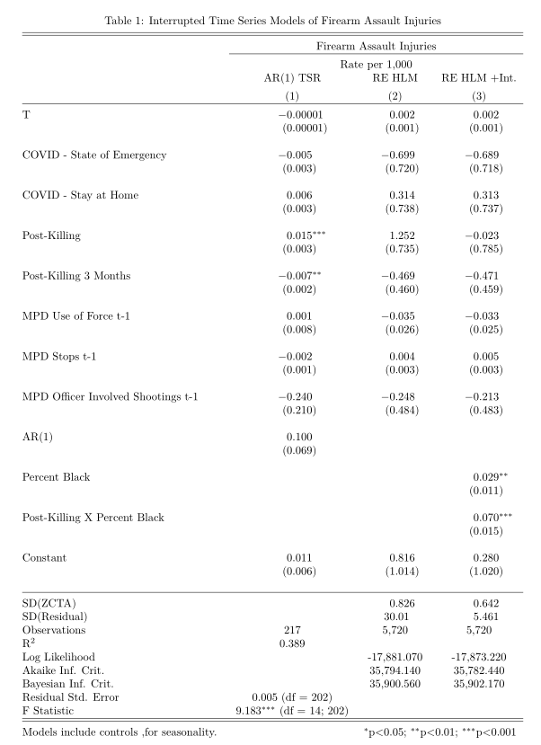

***Spatial Heterogeneity in Post-Killing Effects***

Model 3 in Table 1 relays the results of a random effects model that includes a cross-level interaction between the post-killing time indicator and ZCTA percent Black, which allows the post-killing effect to vary conditional upon the percent Black in a given ZCTA. The statistically significant interaction effect suggests that the post-killing increase was *greater* in places with higher percent Black, as the interaction term indicates that a one percent increase in percent Black increased the post-killing effect by about .07 violent incidents per 1,000 residents. The main effect of percent Black is statistically significant and positive, indicative of higher levels of violence in Black neighborhoods, consistent with Figure 2. This highlights how the neighborhoods *already experiencing* higher levels of gun assault injury incidence were also those that *experienced the greatest brunt of the increase in Minneapolis post-killing*. Further, the main effect for post-killing is statistically nonsignificant, and reverses sign, suggesting ZCTAs with no or very few Black residents did not experience a significant increase in gun assault injury incidence. Figure 3 plots the interaction effect from Model 3, showing that ZCTAs characterized by one standard deviation above the average in percent Black experienced far greater post-killing increases as compared to ZCTAs at below average levels of Black residents. These spatiotemporal patterns indicate the heterogeneous spatial effects of the police killing of George Floyd, as not all spaces in Minneapolis experienced the magnitude of post-killing increase, or any increase at all, as economically disadvantaged, Black neighborhoods did. .

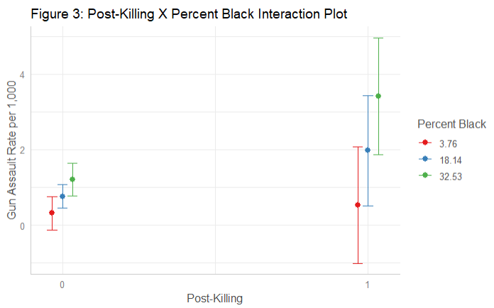

**Homicide Data and the Robustness and Persistence of Results**

Our analysis focuses on the 2020 calendar year when complete hospital data and information on key covariates are available. Although 2021 injury data are not yet available, we can provide descriptive information on the spatial and temporal pattern in Minneapolis homicides to examine the robustness and persistence of patterns identified above. Figure 4 displays the weekly murder rate using Minneapolis Police Department data from 2016-2021.[3] Although homicide rates are much lower than gun assault rates (as gun homicides represent a small part of overall gun assaults), the post-killing spike observed in the hospital data is also present in the homicide data, with a jump from roughly .001 murders per 1,000 residents to .01 murders per 1,000 at its weekly peak, a ten-fold increase. Incorporating data from 2021 further contextualizes the potential longer-term impact of the murder of Mr. Floyd and the longer-term impact of police violence. Weekly homicide rates did *not* return to their pre-killing levels in 2021, maintaining a mean weekly murder rate per 1,000 residents of about .003. This weekly rate is significantly higher than the pre-killing mean of .0001 (Welch’s *t*(60.3) = 5.8, *p* <.001).

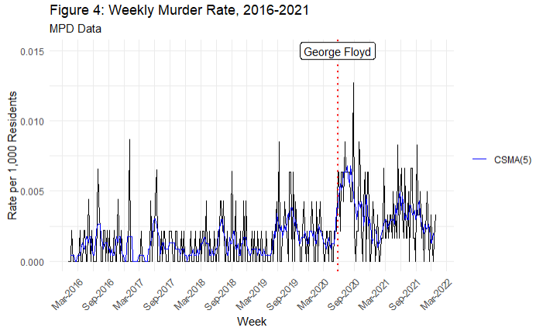

Figure 5 similarly contextualizes the spatial findings using geolocated Minneapolis Police Department homicides into 2021. The spatial location of each MPD murder event is the *incident* ZCTA, rather than the patient’s *residence* ZCTA in the hospital administrative data, so the spatial rates here are not directly analogous.[4] Although the weekly homicide rates are lower than that of the gun assault incidence, we observe a similar spatial pattern in post-killing increases in homicides. Further, while we also see a similar decline in the 3+ months post-killing period from the initial three months post-killing with the inclusion of 2021 into this period, the weekly murder rates do *not* return to pre-killing levels for certain ZCTAs, indicating that, for some communities, the elevated rates of violence persisted into 2021.

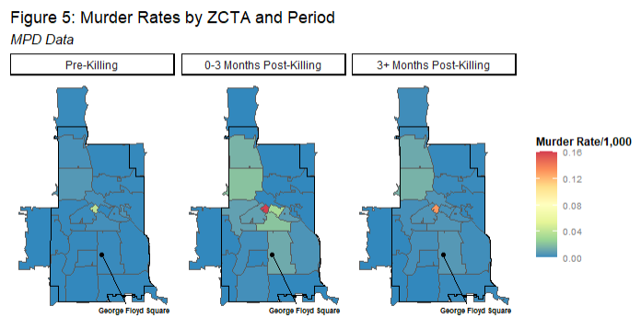

**Discussion**

We find that firearm assault injury rates spiked dramatically and then declined in Minneapolis after the murder of George Floyd by police, even in models that adjust for seasonality, changes in police behavior, and COVID-19-related state policy changes. Further, our models indicate that changes in police behavior did not drive the temporal changes in gun assault injuries, which suggest that “de-policing,” to the extent it occured post-killing, did not play a primary role in driving gun violence upwards. These findings reveal a “Minneapolis effect,” wherein extreme and high-profile police killing significantly altered the temporal pattern of firearm assault injuries. This finding is also consistent with past studies of cities such as Baltimore after the Freddie Gray police killing (*11*). The present study, however, adds important information to this literature by considering a measure of gun violence that is less prone to bias or selection concerns

Although a full exploration of the mechanisms for this increase is beyond the scope of our analysis, the localized and racialized patterns we observe are consistent with accounts based on structural racism, legal estrangement and legal cynicism. We find that communities already experiencing higher levels of social disadvantage and firearm incidence had disproportionate increases in firearm assault injury after the murder of Mr. Floyd. In fact, the neighborhoods that suffered the greatest losses in 2020 and 2021 were precisely the sites of previous police maltreatment and uprisings against police violence in the 1960s (*14*). These findings speak to the traumatizing effects of police violence and the short- and long-term consequences for communities, particularly Black communities (*2*). We caution that our data and analysis are limited to a single jurisdiction in a period of large-scale social change in response to COVID-19, economic recession, and social unrest. Further research is clearly needed to elucidate these processes, but the pattern of findings is consistent with the idea that police violence impacts vulnerable communities by destabilizing social order and threatening public safety.

**References and Notes**

1. Ssentongo, P., Fronterre, C., Ssentongo, A.E. Advani, S., Heilbrunn, E., Hazleton, J., Oh, J., McCall-Hosenfeld, J., Chinchilli, V. Gun violence incidence during the COVID-19 pandemic is higher than before the pandemic in the United States. *Scientific Reports* **11**, 20654 (2021).
2. Muller, C. Exclusion and exploitation: The incarceration of black Americans from slavery to the present.” *Science* **374(6565)**, 282-286 (2021).
3. Page, J., & Soss, J. The predatory dimensions of criminal justice.” *Science* **374(6565)**, 291-294 (2021).
4. Nummi, J., Jennings, C., & Feagin, J. #BlackLivesMatter: Innovative black resistance. *Sociological Forum* **34**, 1042-1064 (2019).
5. Edwards, F., Lee, H., & Esposito, M. Risk of being killed by police use of force in the United States by age, race–ethnicity, and sex. *Proceedings of the National Academy of Sciences* **116 (34)**, 16793-16798 (2019).
6. Jany, L. and Sawyer, L. Gun violence soars amid crises of health, public trust, officer reluctance.” *Star Tribune*, **June 20** <https://www.startribune.com/surge-in-gun-violence-tests-minneapolis-leaders/571524202/> (2020).
7. Shjarback, J. A., Pyrooz, D. C., Wolfe, S. E., & Decker, S. H. De-policing and crime in the wake of Ferguson: Racialized changes in the quantity and quality of policing among Missouri police departments. *Journal of Criminal Justice* **50**, 42-52 (2017).
8. Federal Bureau of Investigation. FBI releases 2020 crime statistics”. Retrieved 9/29/2021 <https://www.fbi.gov/news/pressrel/press-releases/fbi-releases-2020-crime-statistics> (2021).
9. Rosenfeld, R. Ferguson and police use of deadly force.” *Missouri Law Review* **80**, 1077 (2015).
10. Pyrooz, D. C., Decker, S. H., Wolfe, S. E., & Shjarback, J. A. Was there a ferguson effect on crime rates in large US cities?” *Journal of Criminal Justice* **46**, 1-8 (2016).
11. Morgan, S. L., & Pally, J., <https://osf.io/preprints/socarxiv/nshme/> (2016).
12. Wu, D. T., Moore, J. C., Bowen, D. A., Kollar, L. M. M., Mays, E. W., Simon, T. R., & Sumner, S. A. Proportion of violent injuries unreported to law enforcement.” *JAMA Internal Medicine* **179(1)**, 111-112 (2019).
13. Desmond, M., Papachristos, A. V., & Kirk, D. S. Police violence and citizen crime reporting in the black community. *American Sociological Review* **81(5)**, 857-876 (2016).
14. Marks, S. Civil unrest on Plymouth Avenue, Minneapolis, 1967. *MNopedia, https://www. mnopedia. org/event/civil–unrest–plymouth-avenue–minneapolis–1967* (2019).
15. Walker, K., Herman, M. tidycensus: Load US census boundary and attribute data as 'tidyverse' and 'sf'-ready data frames.” R package version 1.1. [https://CRAN.R-project.org/package=tidycensus](https://cran.r-project.org/package=tidycensus) (2021).
16. Ruggles, S., Flood, S., Foster, S., Goeken, R., Pacas, J., Schouweiler, M., Sobek, M. IPUMS USA: Version 11.0 [dataset]. Minneapolis, MN: IPUMS. <https://doi.org/10.18128/D010.V11.0> (2021).

**Acknowledgments:** Not Applicable.

**Funding:**

Minnesota Population Center  P2C HD041023 (NJS)

Interdisciplinary Population Health Science Training Program T32HD095134 (NJS)

**Author contributions:**

Conceptualization: RPL, NJS, CU

Data Curation: RPL, NJS

Formal analysis: RPL

Funding acquisition: CU

Investigation: RPL, NJS, CU

Methodology: RPL, NJS, CU

Project administration: RPL, NJS, CU

Resources: RPL, NJS

Software: RPL

Supervision: CU

Validation: RPL, NJS, CU

Visualization: RPL

Writing – original draft: RPL, NJS

Writing – review & editing: RPL, NJS, CU

**Competing interests:** Authors declare that they have no competing interests.

**Data and materials availability:** The majority of the data that support the findings of this study are readily available online, such as the IPUMS USA database, The Census Bureau API, the American Community Survey, Minneapolis Police Department Data, Minnesota DNR Daily Weather Data, and Minneapolis School Calendars. However, the Minnesota Hospital Association data is restricted and cannot be publicly shared. However, requests for this data can be submitted. Please see the Supplementary Materials for further details on data location and availability. All code for analysis completed as a part of this study are also available in a GitHub repository (see Supplementary Materials for link).

**Supplementary Materials**

Materials and Methods

1. This measure is calculated via the ‘suncalc’ package in R, which, conditional on the week and location, calculates the sunset on each particular day. We then calculate the time difference between sunset and midnight. We aggregate this to the average amount per day in each to represent our weekly measure of darkness before 12 midnight.
2. A fixed effect specification, which restricts comparison to only within-ZCTA comparisons netting out time constant unobserved heterogeneity, shows similar time period effects. Model available upon request to the authors.
3. A 5-week centered simple moving average (assuming equal weights across the window) is plotted on top of the weekly murder rates in Minneapolis to smooth out the variability present in the week-to-week homicide rates.
4. This is apparent in the spatially small ZCTA 55402, representing downtown Minneapolis. The number of murders is high due to the confluence of people downtown, but the ZCTA has a relatively small residential denominator. This is in contrast to the gun assault rates in 55402, which measures the gun assault incidence for *residents* of 55402, as opposed to overall incidence in the ZCTA.